MCBI61: Business Intelligence Certificate in Business Decision Making with Interpreting Data
UNIVERSITY STUDENT MENTAL ISSUES ANALYSICS
Assessment 2
CHENTONGWANG

February 9, 2026

Table of Content
1. Introduction 2
2. Exploratory Data Analysis 2
3. Diagnostic Analysis 8
4. Insights 10
5. Review and Revise business questions 12
6. Conclusions 13
7. References 13

Introduction
  - Business Scenario
The mental health issue of university students is always a priority for societies and educational departments worldwide. As the life pace becomes faster, more university students are identified as having mental health problem. The Psychological Health Association discovers that the ratio of university students suffering from various psychological diseases increased significantly in Bangladesh in the past years. To figure out what significantly affects the mental well-being of college students, the organization collects various information of university students including personal characters (genders, ages), academic levels (departments, CGPA, university levels, academic years) and financial status (wavier or scholarship) in Bangladesh, and their feedbacks about three typical mental issues which are anxiety, stress and depression. In this scenario, data analysis will provide valuable insights into the mental health status of university students in Bangladesh.

  - Business Questions
The questions that this project aims to explore are as follows:
- How do the personal characters affect severe level of three major metal health disorders among university students?
- How does the financial status influence the severity of three metal health issues of university students?
- How do the academic levels affect severe level of three metal health disorders of university students?

Exploratory Data Analysis
  - Total amount of university students with different mental health issue
The most common psychological health issues examined in this dataset include anxiety, stress, and depression. In this study, university students’ mental health status and the severity of these conditions are assessed based on their self-reported emotional and psychological experiences. Each mental health indicator is scored on a scale from 0 to 3 or 0 to 4, and the total score for each category is used to determine whether a student is experiencing the condition and to what level of severity. There is total 1977 students participating in this survey (Malak Elhawary,2023).

For anxiety, students evaluate themselves based on whether they experience symptoms such as feeling nervous or anxious, excessive worrying, trouble relaxing, being easily annoyed or irritated, worrying too much, restlessness, or feeling afraid. The total score from these items is used to determine the severity of anxiety:
- 0–4: Minimal anxiety,
- 5–9: Mild anxiety,
- 10–14: Moderate anxiety,
- 15–21: Severe anxiety.

For stress, students evaluate themselves based on whether they experience symptoms such as feeling upset, lacking control, nervous/stressed, overwhelmed, confident, everything okay, be able to control irritations, performance perfectly, angry due to bad performance, have academic difficulties. The total score from these items is used to determine the severity of stress:
- 0-13: Low stress,
- 14-26: Moderated stress,
- 27-40: High perceived stress.

For depression, students evaluate themselves based on whether they experience symptoms such as interest lack, feeling down, sleep issues, fatigue, appetite, self-doubt, concentration issues, movement issues, suicidal thoughts. The total score from these items is used to determine the severity of depression:
- 0: No depression,
- 1-5: Minimal depression,
- 6-9: Mild depression,
- 10-14: Moderate depression,
- 15-19: Moderately severe depression,
- 20-27: Severe depression.

These three pie charts illustrate the proportion of students experiencing different levels of mental health issues. They provide analysts with a clearer and more intuitive understanding of the extent to which these psychological conditions affect university students.

  - Personal Characteristics Influence for University Students
This study aggregates personal demographic characteristics including gender and age. Pivot tables were created to examine whether age and gender are significant factors contributing to severe anxiety, high perceived stress, severe depression.

  - Financial Status Influence for University Students
This study collects financial status which is whether they have scholarships or not. Pivot tables were utilized to investigate whether students’ financial status is associated with a higher likelihood of developing severe mental health issues.

  - Academic Levels Influence for University Students
This study summarizes factors of students’ academic levels including academic year, CGPA, departments and university types. It can be observed that the relationship between students’ academic performance and mental health issues constitutes a primary focus of this data analysis. Different types of charts were created to explore the relationships between multiple influencing element and severe mental issues.

Diagnostic Analysis
This report examines whether demographic and socioeconomic variables—age, gender, and scholarship status—are statistically associated with three mental-health outcomes: Severe Anxiety, High Perceived Stress, and Severe Depression.
All analyses use Chi-Square Tests of Independence, with significance level α= 0.05.
  - Age in Severe Anxiety
Null Hypotheses- H₀: Age group and Severe Anxiety are independent.
Alternative Hypotheses- H₁: Age group and Severe Anxiety are associated.
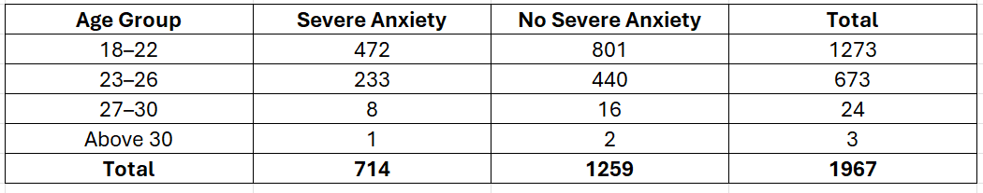
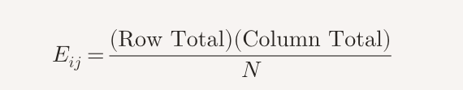
Formula:
All expected Values:
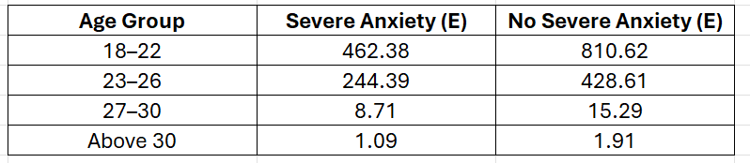
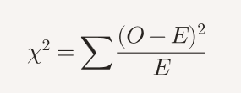
Chi-Square Formula (Scribbr, n.d.):
X²=1.24, P>0.70
There is no statistically significant association between age group and severe anxiety.
  - Genders in Severe Anxiety
Null Hypotheses- H₀: genders and Severe Anxiety are independent.
Alternative Hypotheses- H₁: genders and Severe Anxiety are associated.
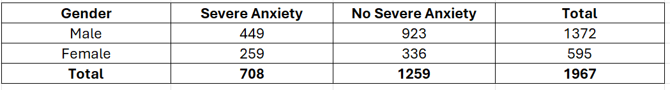
Expected Values:
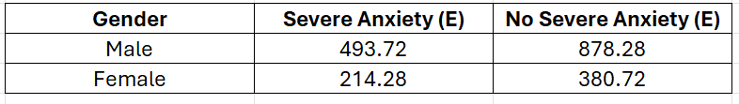
X²=20.96, P<0.001
Gender and severe anxiety are significantly associated.
  - Scholarship in Severe Anxiety, High Perceived Stress and Severe Depression
Null Hypotheses- H₀: scholarship and Severe Anxiety are independent.
Alternative Hypotheses- H₁: scholarship and Severe Anxiety are associated.
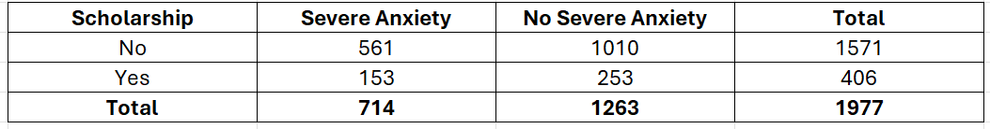
All expected values:
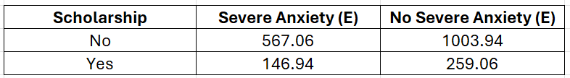
X2=0.49, P>0.48
Scholarship is not significantly associated with severe anxiety.
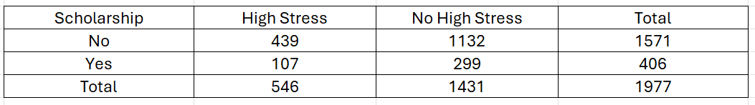
Expected values:
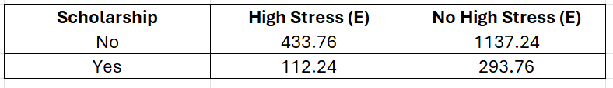
X²=0.41, P=0.52
Scholarship is not significantly associated with high perceived stress.
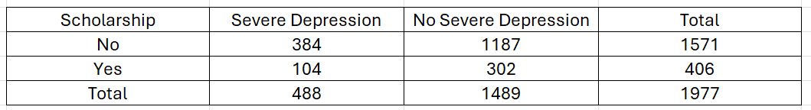
Expected values:
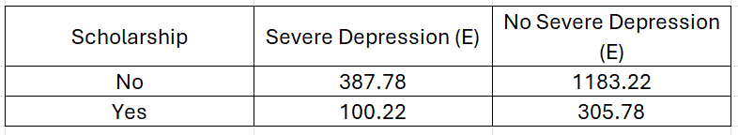
X2=0.24, P=0.62
Scholarship is not significantly associated with severe depression.

Insights
  - Total amount of university students with different mental health issue

By analyzing the proportion of students with different levels of anxiety, it indicates that only 7.99% are classified as having minimal anxiety. In contrast, the proportions of mild, moderate and severe anxiety are considerably higher, with severe anxiety accounting for 36.12%—more than one-third of all respondents.

The pie chart clearly shows that nearly two-thirds of the students are classified as experiencing moderate stress. Only 5.82% of the students are assessed as having low stress, while the proportion of those with high perceived stress is relatively small, at 27.62%.

The distribution of depression levels is very similar to that of stress. Only a small proportion of students are classified as having no depression or minimal depression. The majority fall within the mild, moderate, or moderately severe categories, and together these groups account for nearly three-quarters of all respondents. Severe depression represents 24.68% of the students.

Overall, among the surveyed students, the three severe mental health disorders together account for nearly one-quarter of the total population, and comparatively, the number of students with severe anxiety is higher.

  - Personal Characteristics Influence for University Students

Personal characteristics include gender and age. The clustered chart illustrates that among female students, 259 individuals present with severe anxiety, 214 exhibit high perceived stress, and a comparatively smaller group of 180 experience severe depression. Among male students, 449 cases of severe anxiety are observed, along with 328 instances of high perceived stress, while the number of severe depression cases remains at a comparable level. Across all age groups, the number of students exhibiting severe anxiety consistently exceeds those experiencing high perceived stress or severe depression.

It is evident that both genders and ages show a consistently higher prevalence of severe anxiety relative to other severe psychological conditions.

  - Financial Status Influence for University Students

bar chart indicates that, across severe depression, severe anxiety, and high perceived stress, the number of students without scholarships is substantially higher than those with scholarships, suggesting that scholarship status may influence the prevalence of severe mental health disorders.

  - Academic Level Influence for University Students

The line chart shows that the patterns of severe mental health disorders vary slightly across different departments. In the Engineering–CS department, the number of students experiencing severe anxiety is noticeably higher than those with the other two disorders. However, in the Engineering–EEE department, the number of students with high perceived stress slightly exceeds those with severe anxiety. These variations suggest that no consistent or strong association can be established between department and any specific severe mental health condition. Similarly, across different universities, no single disorder consistently appears at a higher level than the other two. Therefore, the data do not provide evidence of a clear relationship between university type and the prevalence of any particular severe mental health disorder. The stacked column chart shows that academic year has minimal influence on the prevalence of severe mental health disorders, and a similar pattern is observed with respect to CGPA.

Review and Revise business questions
Based on the exploratory data analysis and diagnostic analysis, the business questions should be reviewed and refined with the following lists of questions which could be further investigated and answered.

- How do the personal characters affect severe level of three major metal health disorders among university students?
  - Is age a significant factor in causing severe anxiety, high perceived stress, severe depression?
  - Is gender an influence on developing severe anxiety, high perceived stress, severe depression?
- How does the financial status influence the severity of three metal health issues of university students?
2.1 Is scholarship an important element on developing severe anxiety, high perceived stress, severe depression?
- How do the academic levels affect severe level of three metal health disorders of university students?
  - About all factors in academic levels, which factor influence on developing severe anxiety, high perceived stress, severe depression?
  - What are the proportional contributions of the various factors to each of these mental metal disorders?

Conclusions

This report investigates whether various factors influence the mental health conditions of university students. Through the EDA, the proportional distributions of students indicate clear patterns across age, gender, and scholarship status. The subsequent diagnostic analysis further tests the statistical associations among these factors. Based on the P-values, gender is found to have a significant association with severe anxiety. Although age and scholarship status appear to show patterns in the descriptive data, the statistical tests do not provide sufficient evidence to confirm significant associations.

References
Scribbr. (n.d.). Chi-square (χ²) tests: Definition, types & examples. https://www.scribbr.com/statistics/chi-square-tests/
Malak Elhawary. (2023). University Students' Mental Health [Data set]. Kaggle. https://www.kaggle.com/datasets/malakelhawaryyy/university-students-mental-health

